**1.** **You need to create a function to find the rating of the books that scored the highest rating from feedbacks**

CREATE OR REPLACE FUNCTION best_book_rating RETURN NUMBER AS

v_result NUMBER;

BEGIN

SELECT MAX(f_rating)

INTO v_result

FROM (

SELECT rating as f_rating

FROM feedbacks f

);

RETURN v_result;

END;

select best_book_rating() from dual; 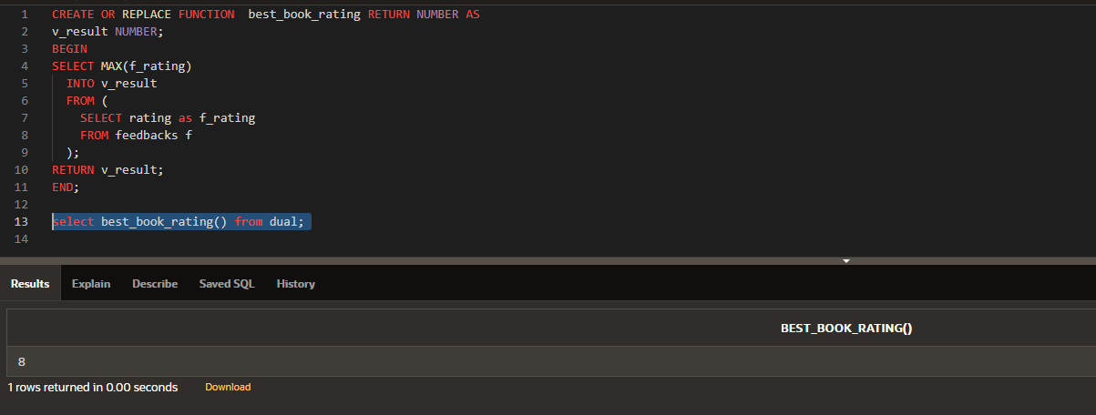

**2. We need to set a price where we have the number of books less than 11 or equal to 1**

DECLARE

b_price books.price%TYPE := 10000;

BEGIN

UPDATE books SET price = b_price WHERE count < 11 or count like '1';

IF SQL%ROWCOUNT = 0 THEN

RAISE_APPLICATION_ERROR(-20002, 'Not found book with less than 11 or equal to 1 counts.');

ELSE

DBMS_OUTPUT.PUT_LINE('Book price is updated:'||b_price);

END IF;

EXCEPTION

WHEN OTHERS THEN

RAISE_APPLICATION_ERROR(-20003, 'ERROR AT TRANSACTION.');

END;

